**FINAL PROJECT OUTLINE:**

**1-person Project:**

•         Database design which contains at least 3 entities and 3 tables

•         Contains all CRUD operations (Create, Read, Update & Delete)

•         **Each entity** should have at least one**CRUD operation**

•       **AND:**one or more entities needs to have all 4 CRUD operations (Create, Read, Update & Delete).

•         Contains at least 1 one-to-many relationship

•         Contains at least 1 many-to-many relationship with one or more CRUD operations on this relationship

•         **Required**:  **REST Web API Server**tested through Swagger, Postman or AdvancedRestClient (ARC) or a front-end client.

**Proposal Template:**

**Project Participants:**

DANA HUSTED

**Title:**

MassageStudio

**Executive Summary:**

This program will store Massage Therapy Business MassageStudios, Therapists, Customers, and Modalities. It will be able to add/ delete/ and edit information for MassageStudios, Therapists, Customers. And it will assign modalities to each Therapist’s ability.

**Initial Features:**

**Create a bulleted list of Initial Features**.This will be a list of features that meet the requirements of the final project.

* ERD Database Design: add join table to ERD

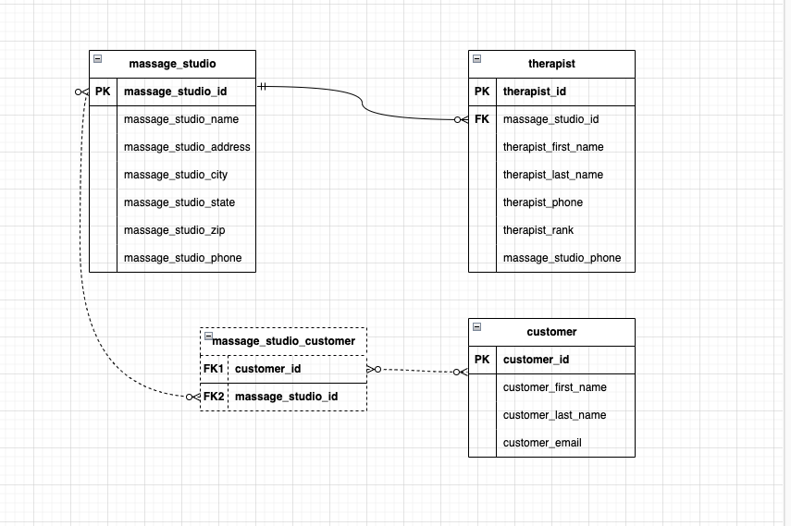

* **Entities:** MassageStudio, Therapist, Customer
* Browse all MassageStudios (GET on MassageStudios) – without listing all customers and therapists
* GET all Customers
* GET all Therapists
* Browse all customers by MassageStudio (GET on Customers with MassageStudio specified)
* Browse therapist by MassageStudio (GET on Therapist with MassageStudio specified)
* GET for the join table – is this just the same as above, get all customers?
* Create new MassageStudio (POST on MassageStudio)
* Add new Therapist to a MassageStudio (POST on Therapist with MassageStudio specified)
* Add new Customer to a MassageStudio (POST on Customer with MassageStudio specified)
* Delete MassageStudio (DELETE) – deletes all associated therapists, without deleting all customers
* Update MassageStudio (PUT on a specific MassageStudio)

**Stretch Goals (to be completed if time allows, or after graduation):**

**Create a bulleted list of Stretch Goals**:

* Add mobile Therapist
* Different rooms within each MassageStudio
* Book an appointment at a MassageStudio (POST on book)*.*

**Final Reminders:**

* This project should be written following the pattern implemented in one of the following projects:  **pet-parks**, **dog-rescue** or **pet-store**.
* **Use JPA to create a REST API Server.   Test your REST API Server using Postman, Swagger, or AdvancedRestClient (ARC).**

Github:

<https://github.com/dlhusted/Spring-Boot-Final-Project/tree/main>

youtube:

<https://youtu.be/WEOgW2PNh1E>